The Window Source of Orlando: Upgrade Your Home with Custom Windows & Doors Today

**Business Name:** [The Window Source of Orlando](https://windowsourceorlando.com/)

**Address:** 174 Semoran Commerce Pl Suite 125B, Apopka, FL 32703, United States

**Website:** https://windowsourceorlando.com/

**Phone:** +1 321-336-0230 | (321) 336-0230

**Visit Our Website:** *https://windowsourceorlando.com/*

**Social Link:** [*https://www.facebook.com/windowsourceorlando/*](https://www.facebook.com/windowsourceorlando/)

**Business/Contact mail:** [seo@windowsourceorlando.com](mailto:seo@windowsourceorlando.com)

**Business Hours:** Monday to Friday: 9 AM–5 PM | Saturday & Sunday: Closed

**Accepted Payment:** Cash & Credit

It is a Family-owned window company in Apopka, FL, that offers expert installation, energy-efficient windows, and doors with over 15 years of experience.

[](https://windowsourceorlando.com/)

The Window Source of Orlando is a locally owned and family-operated business proudly backed by a trusted national brand. We specialize in providing high-quality, custom-designed windows and doors tailored to fit your home’s unique style and needs.

With over 15 years of professional installation experience, our skilled technicians deliver exceptional workmanship and reliable service. From consultation to completion, our goal is to make your window and door replacement process smooth, positive, and enjoyable—an experience you’ll be happy to share with friends and family.

[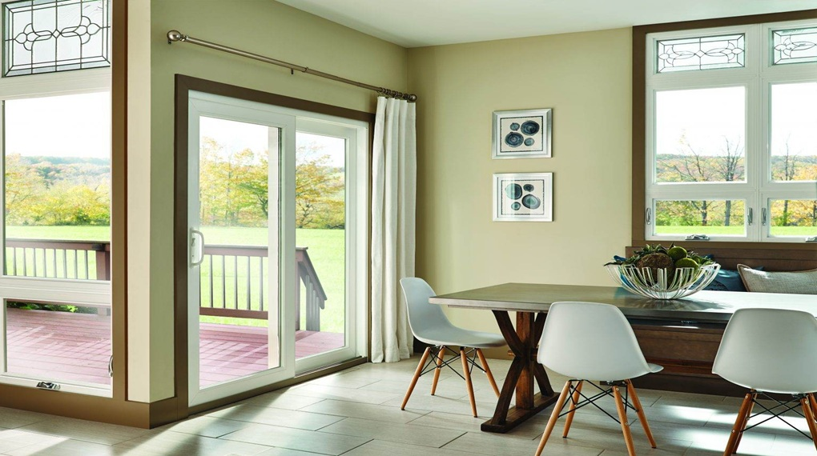](https://www.facebook.com/windowsourceorlando/)

## Business Service & Products Type

* Window Replacement
* Door Replacement
* Window Installation
* Orlando Window Company
* Custom Windows Orlando
* Energy Efficient Windows
* Home Improvement
* Residential Windows
* Sliding Glass Doors
* Window Repair Services
* Orlando FL Windows
* Central Florida Home Services
* Apopka Window Company
* Florida Window Installers
* Local Window Experts Orlando
* The Window Source of Orlando
* Family Owned Window Company
* Trusted Window Experts
* Experienced Installers Orlando
* High-Quality Windows Orlando
* Vinyl Windows
* Double Hung Windows
* Picture Windows
* Bow and Bay Windows
* Entry Doors Installation

[The Window Source of Orlando](https://windowsourceorlando.com/) is run by Jeremy, Samantha, and his brothers Chris and James. They handle warehouse work and install windows and doors with care.

**Category:**

Window-Door Company/Installation, Home Improvement, Home Services, Contractor, General Contractor, Professional Services

**Services/Products - Windows, Doors**

**Windows:** Double Hung, Sliding, Casement & Awning, Bay and Bow, Color & Style Options, Energy Saving Glass

**Doors:** Sliding Patio, and Entry Doors